AML Transaction & Fraud Analysis

Using Microsoft Power BI Desktop
Project Report
Submitted by: M. Cheathana
Tool used: Microsoft Power BI Desktop

1. Introduction
Anti-Money Laundering (AML) and financial fraud surveillance represent critical components of modern financial intelligence and regulatory compliance frameworks. Financial institutions process millions of high-frequency transactions daily, making automated visual analytics essential for identifying suspicious behavioral topologies such as money laundering cycles and rapid aggregation patterns (fan-in).

This project presents an interactive visual analytics solution developed in Microsoft Power BI Desktop to evaluate transaction volumes, monitor high-risk transaction flags, distinguish fraudulent behavior, and analyze alert typologies across financial account networks.

2. Objectives
- Quantify Core Operational Metrics: Track high-level KPIs including total transaction volume, total financial exposure value, monitored account base, and flagged fraudulent instances.
- Temporal Trend Analysis: Examine continuous temporal trends in overall transaction volume versus illicit volume across discrete timestamp iterations.
- Typological Distribution: Evaluate alert volume across defined AML typologies, specifically circular money routing (cycle) and multi-source concentration to a single destination (fan_in).
- Exposure Segmentation: Measure financial risk by segmenting aggregate monetary volume across legitimate (False) and fraudulent (True) transactions.
- Prevalence Modeling: Determine baseline fraud rates relative to total throughput to assess systemic risk profiles.
- Interactive Investigation: Implement dynamic slicers enabling compliance officers to isolate specific transaction behaviors and alert classes rapidly.

3. Dataset Description
The underlying data model comprises structured financial transaction log records tailored for AML pattern detection.

Field / Metric | Observed Dimension / Value | Analytical Scope
Total Transactions | 1,000,000 records | Full population across the monitoring window
Total Transaction Amount | $153.48 billion | Aggregate monetary volume ingested
Total Accounts | 10,000 unique entities | Originating and destination accounts monitored
Fraudulent Transactions | 2,000 records | Verified illicit transaction events
Timestamp Range | 0 to 200 | Normalized sequential time steps
Alert Typologies | cycle, fan_in | Primary structural money laundering vectors
Fraud Indicators | True, False | Categorical classification outcome

4. Data Preparation
- Extraction & Ingestion: Raw transaction datasets were loaded into Microsoft Power BI Desktop via the native data connector engine.
- Profiling & Data Quality: Audited data types across timestamps, monetary values, and flags. Verified the absence of null values or incomplete key pairings.
- Data Modeling: Constructed an optimized, flat data structure to ensure performant execution of DAX aggregations across 1,000,000 rows.
- Standardization & Formatting: Applied standard currency representations in billions ($bn), consolidated numeric volume formats (K and M), and validated clean categorical fields.

5. DAX Measures Used
Total Transactions = COUNTROWS('Transactions')

Calculates the total count of transaction records ingested (Result: 1M).Total Transaction Amount = SUM('Transactions'[Transaction_Amount])

Aggregates total monetary transaction value across all rows (Result: 153.48bn).Total Accounts = DISTINCTCOUNT('Transactions'[Account_ID])

Counts unique originating and destination financial accounts (Result: 10K).Fraudulent Transactions = CALCULATE(COUNTROWS('Transactions'), 'Transactions'[IS_FRAUD] == TRUE)

Filters and counts records flagged with verified fraudulent status (Result: 2K).Total Transaction Value by Fraud Status =

SUMX(

VALUES('Transactions'[IS_FRAUD]),

CALCULATE(SUM('Transactions'[Transaction_Amount]))

)

Evaluates monetary exposure distributed across False and True fraud classifications.

6. Dashboard Components

KPI Cards (Top Banner)
- Total Transactions: Displays 1M aggregate operations.
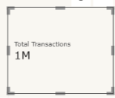
- Total Transaction Amount: Displays $153.48bn cumulative monetary exposure.
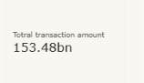
- Total Accounts: Tracks 10K unique customer account profiles.

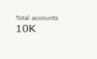
- Fraudulent Transactions: Isolates the 2K verified fraud instances.

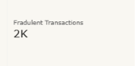

Trend Line Charts (Middle Section)
- Transaction Volume Across Timestamp: Line visual illustrating operational volume stability, maintaining consistent baseline throughput between 5,000 and 7,000 transactions per timestamp unit (0 to 200).
- Fraudulent Transaction Volume Across Timestamp: Line visual charting illicit volatility over time, highlighting irregular operational spikes reaching up to 15 to 17 fraudulent transactions in select windows.

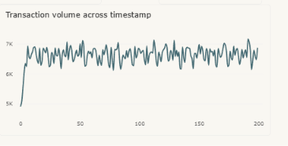

Bar & Column Visuals (Bottom Section)
- Alert by Alert Type: Horizontal bar chart demonstrating a balanced distribution across cycle and fan_in detection patterns (representing approximately 1.3M rule evaluations across logged vectors).

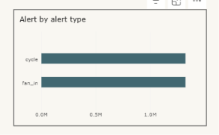
- Total Transaction Value by Fraud Status: Column visual confirming that the overwhelming share of the $153.48bn total volume corresponds to non-fraudulent activity (False), containing fraudulent transaction values to a controlled subset.

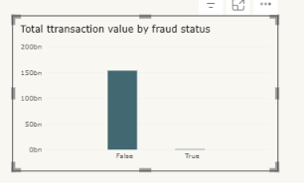
- Transaction Distribution by Fraud Status: Donut chart contrasting legitimate transaction share (1M / 99.87%) with confirmed fraudulent transactions (~0M / 0.13%).

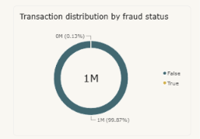

7. Slicers Used
- ALERT_TYPE Slicer: Single- and multi-select filter featuring cycle and fan_in categories, isolating visual metrics by specific network topology.

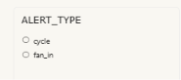
- IS_FRAUD Slicer: Boolean selector toggling between False and True, allowing compliance teams to decouple baseline legitimate activity from high-risk forensic targets.

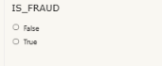

8. Key Findings
- Low Prevalence Baseline: Flagged fraud constitutes 0.13% of total throughput (2,000 of 1,000,000 records), presenting a classic sparse detection challenge representative of production banking networks.
- Stable Core Operations: General transaction activity runs at uniform velocity, oscillating predictably between 5K and 7K transactions per interval without systemic deviations.
- Clustered Illicit Spikes: In contrast to overall stability, fraudulent activity presents in concentrated bursts, notably around timestamps 15, 45, 140, and 170.
- Balanced Typology Frequency: Alert triggers are evenly partitioned between circular patterns (cycle) and rapid account aggregation (fan_in), requiring equal surveillance allocation across both behaviors.
- Controlled Financial Exposure: The majority of the $153.48bn portfolio value remains uncompromised, allowing risk operations to focus intervention on identified high-density intervals.

Overall Dashboard:
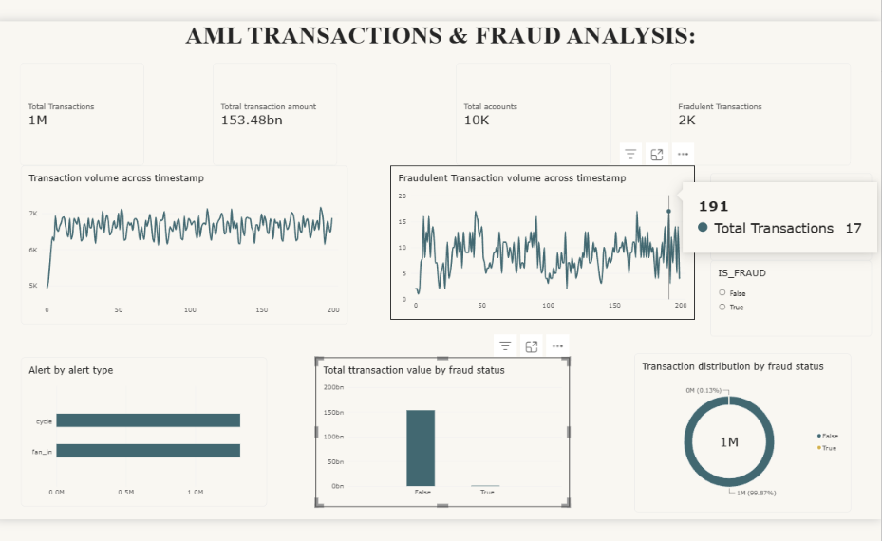

9. Conclusion
The AML Transaction & Fraud Analysis Dashboard in Microsoft Power BI Desktop converts high-volume transaction telemetry into actionable compliance intelligence. By centralizing 1M records, 10K accounts, and core DAX measures into high-level KPI cards, temporal tracking charts, and typology breakdowns, the dashboard enables investigative teams to isolate circular transfers, intercept aggregation vectors, and mitigate systemic institutional fraud exposure.

